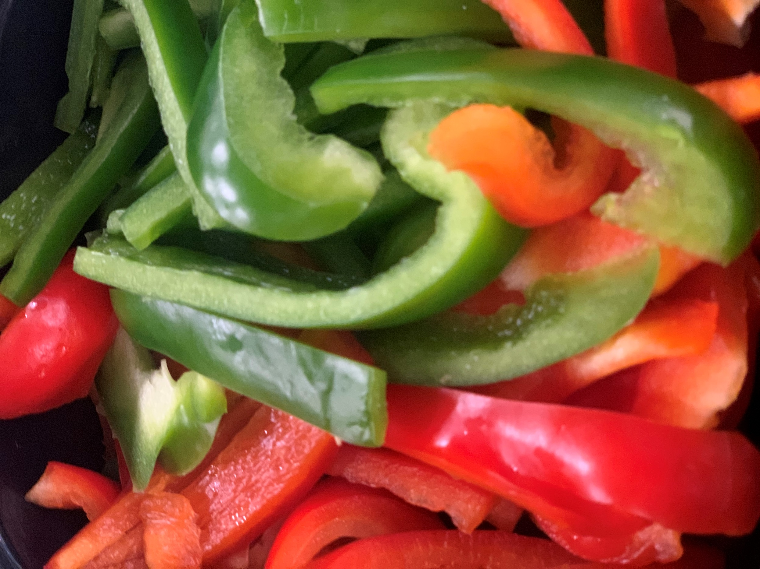

**2**

**30**

**29**

**28**

**27**

**26**

**21**

**23**

**22**

**202**

**19**

**16**

**15**

**14**

**13**

**12**

**9**

**8**

**7**

**6**

**5**

**1**

**New 2022/2023**

**To order Deli**

**Sweet& Sour Chicken**

Rice

Veggie

Fruit

**This Institution is an Equal Opportunity Provider**

Service Time:

7:15-12:50

Free Breakfast

7:15

***Any questions or concerns about the Nutrition Services Program?***

**Please contact:**

**Food Service Director: Lorrie Wanty** [**LWanty@hgsd.k12.wi.us**](mailto:LWanty@hgsd.k12.wi.us)

**\***



Lunch Prices

Northview: $3.00

Middle School: $3.30

High School: $3.30

**Pizza /Cheese**

Marinara

Bread Stick

Fruit

**Sloppy Joe**

**Chips**

Veggie

Fruit Cocktail

Muffin

**Enchilada Casserole**

**Spanish Rice**

**Elote**

**Fruit**

**Pizza /Cheese**

Marinara

Bread Stick

Fruit

**Sloppy Joe**

**Chips**

Veggie

Fruit Cocktail

Muffin

**Soft Shell Taco**

Refried Beans

Veggie

Fruit

**Pizza Quesadillas**

Marinara Cup

Veggie

Peaches

Chicken Alfredo

Or Alfredo Pasta

Garlic Bread

Broccoli

Fruit

**Salisbury Steak**

Mashed Potatoes

Corn

Dinner Roll WG

Peaches

**Chicken Taco**

Toppings

Refried Beans

Fruit

**Pancakes**

Sausage

Pattie

Tator Tots

Fruit

Muffin

**Cheeseburger** Potato Wedges

Baby Carrot’s

Pears

**Chicken Bowl**

Mashed Potato

Corn

Shredded Cheese

Fruit

Cookie

Fruit

Closed

**Chicken Tenders**

French Fries

Veggie

Fruit

**Chicken Nuggets**

Potato Wedges

Applesauce

Veggie

Mini Corn Dogs

Tator Tots

Fruit

Veggie

Howards Grove High School

Lunch Menu September 2022

January

**Chicken Cordon Bleu Sandwich or**

Sidewinder Fries

Fruit

**Brat**

Baked Beans

Mac N Cheese

Peaches

Coleslaw

**Nachos**

Corn Bread

Refried Beans

Fruit

Pudding Cup

**Spaghetti**

**Garlic Bread**

**Veggie**

**Fruit**